
Packet Sniffing and Spoofing

LAB Setup Environment
- Run the SEED VM>> open Firefox in that>> go to the seed labs,
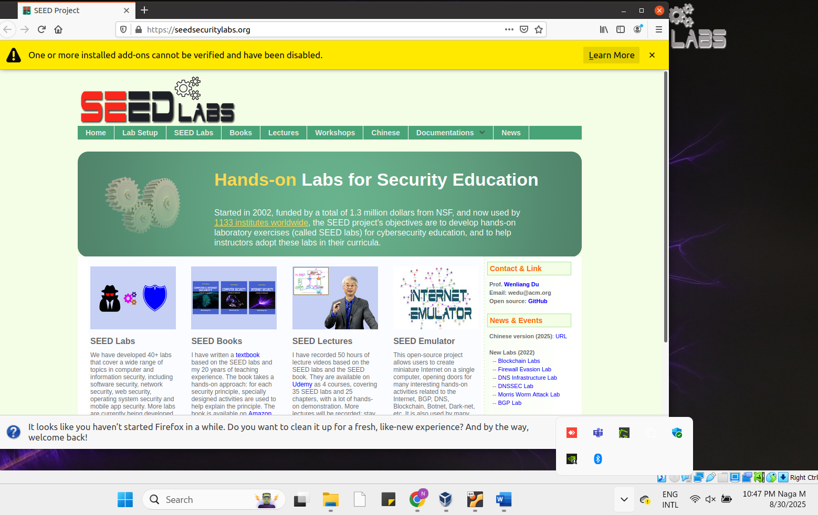
How to Download the lab setup zip file.>> click on the seed labs >> network security>> packet sniffing and spoofing.

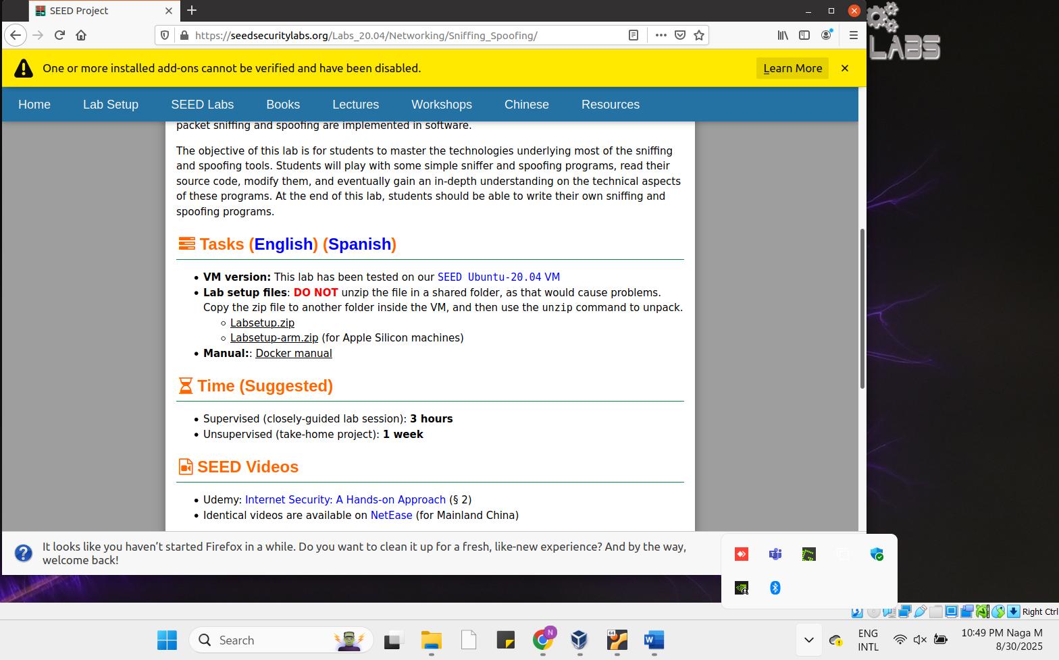

Copy this zip to Documents(any other folder in VM), here I moved it to documents >> sniff lab>> there unzip the labsetup.zip file. From here right click and open the Terminal then we can directly move to Terminal
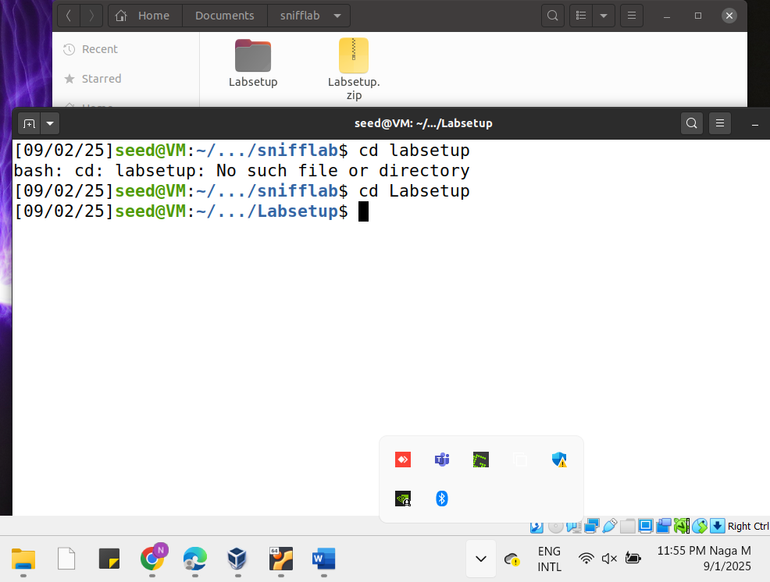

Now, We need to Set up Containers,
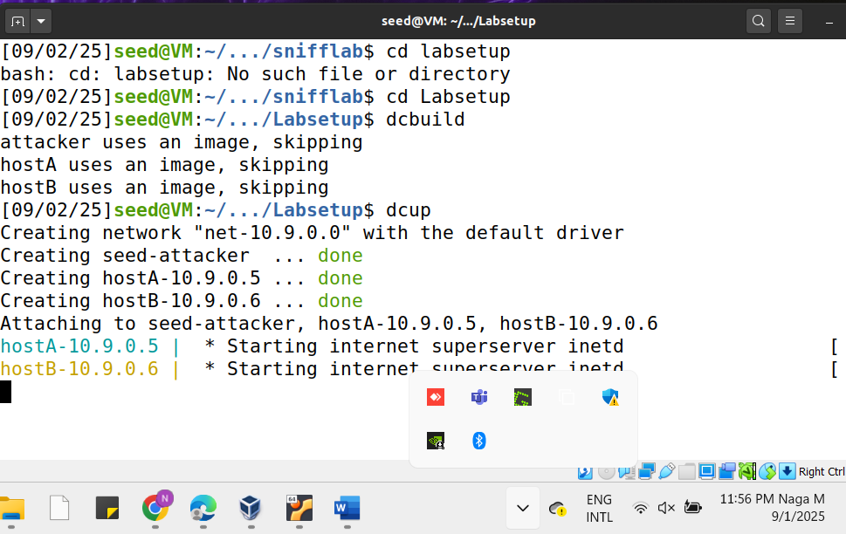

Open the another teminal in that type dockps
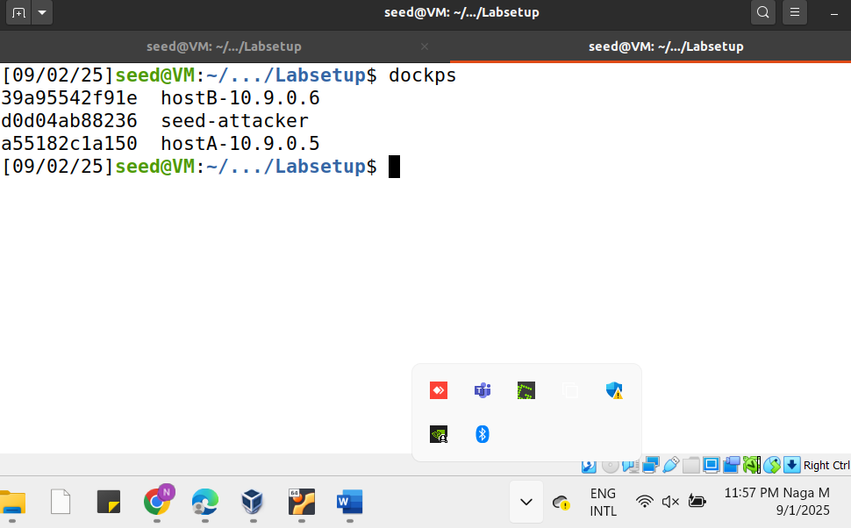

Here we can see that the seed-attacker container and that id is d0, So we can run the command docksh d0
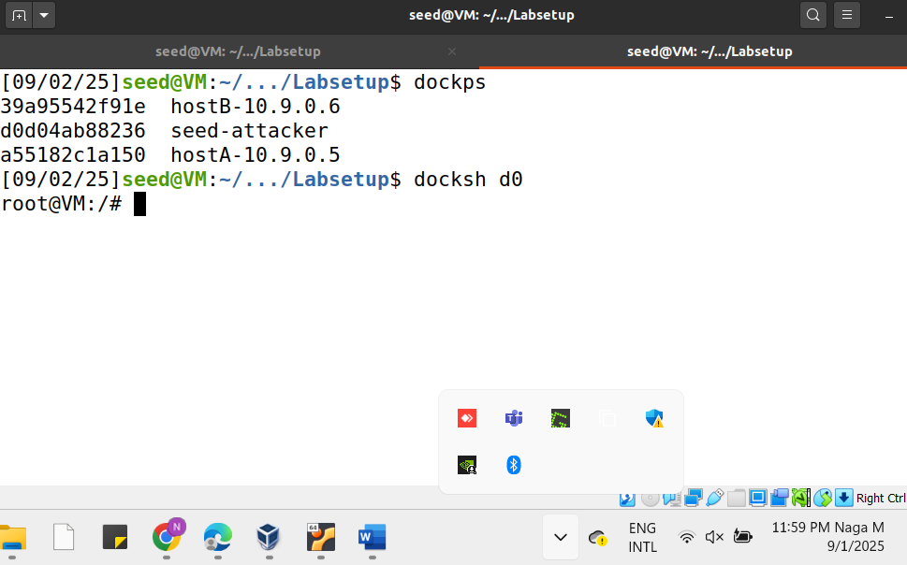

After that we can enter that root.. we can check the ip address by using the ifconfig command
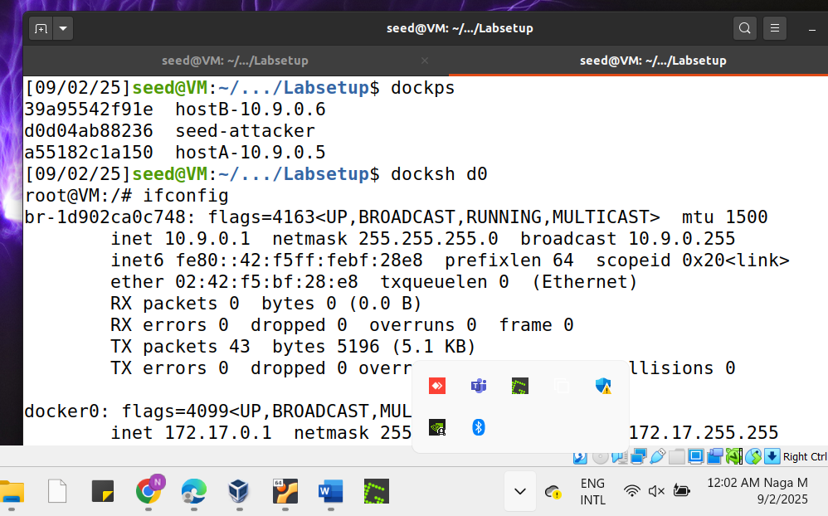

LabTaskSet1: Using Scapy to Sniff and Spoof Packet
Crete a .py file in that . For that open a new terminal and use the command touch mycode.py
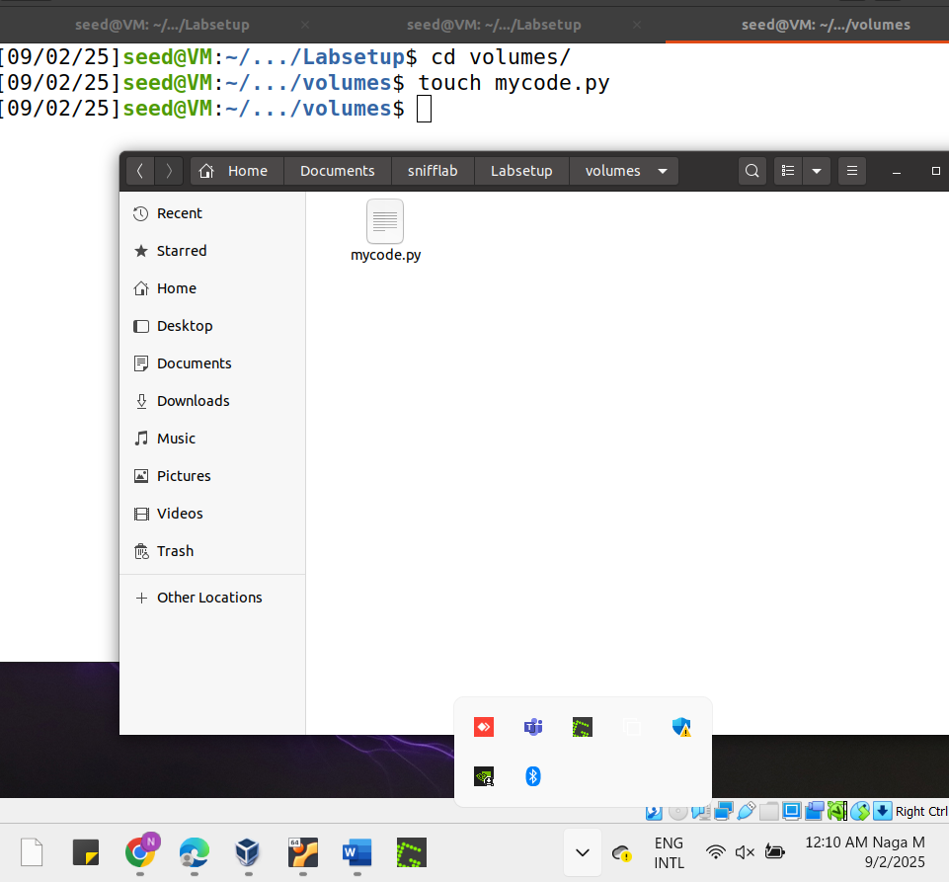

After the command execution, we can immediately fine a mycode.py file in the lab setup file. Double click on that file and write the python code and save it and close.
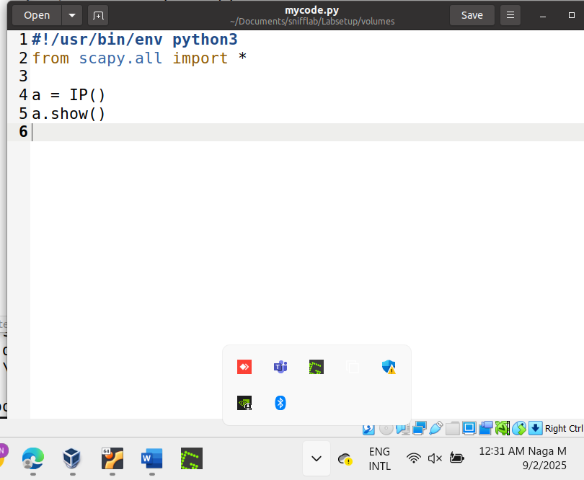
Now open the root terminal and execute the mycode.py file, for that we need to use the chmod a+x mycode.py file, and then we can see the output of our system IP address details.

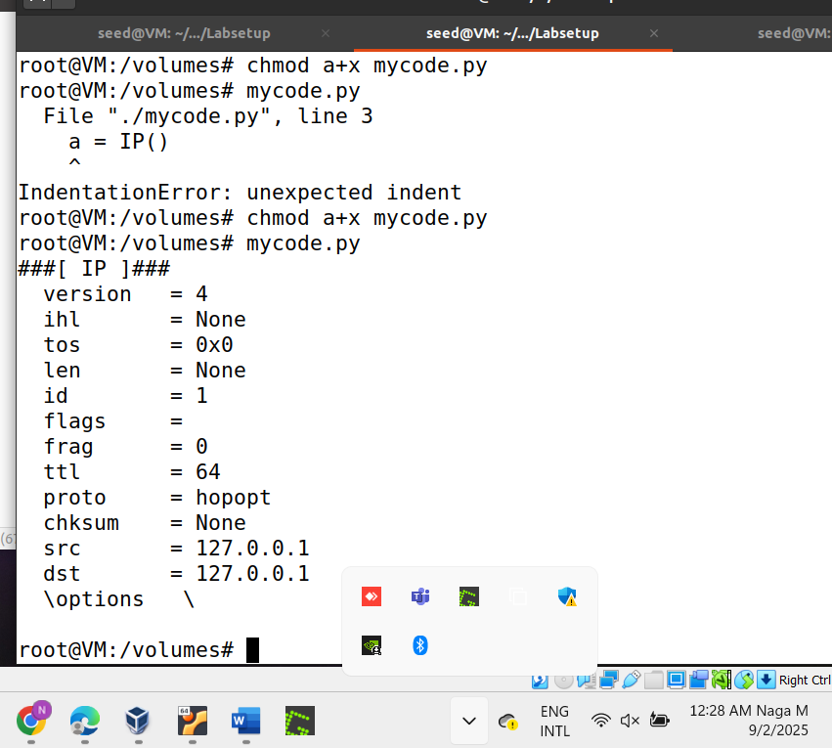

Task1.1:SniffingPacket
Create a sniffer.py file by using nano command and write the simple python code, and replace the interface id as we already seen in one of the above screenshots(ifconfig). Save the fie.
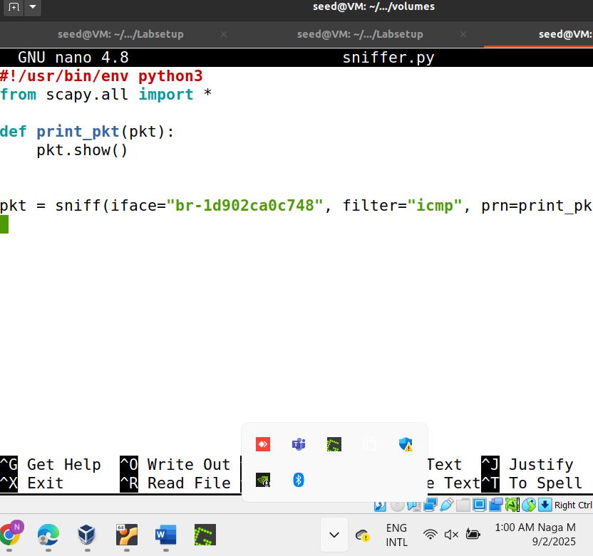

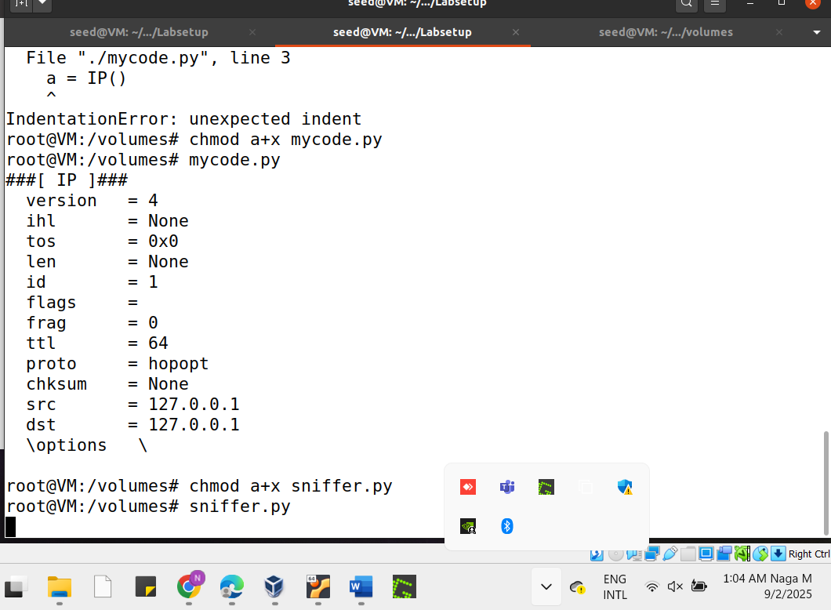
Lets ping host B and in the root terminal execute the sniffer.py file.
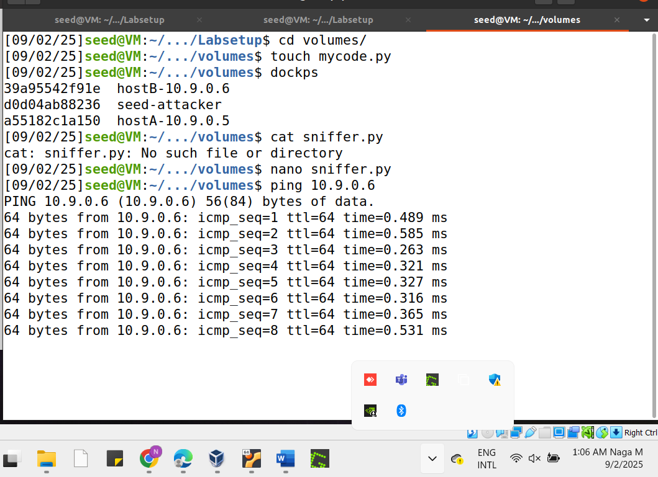

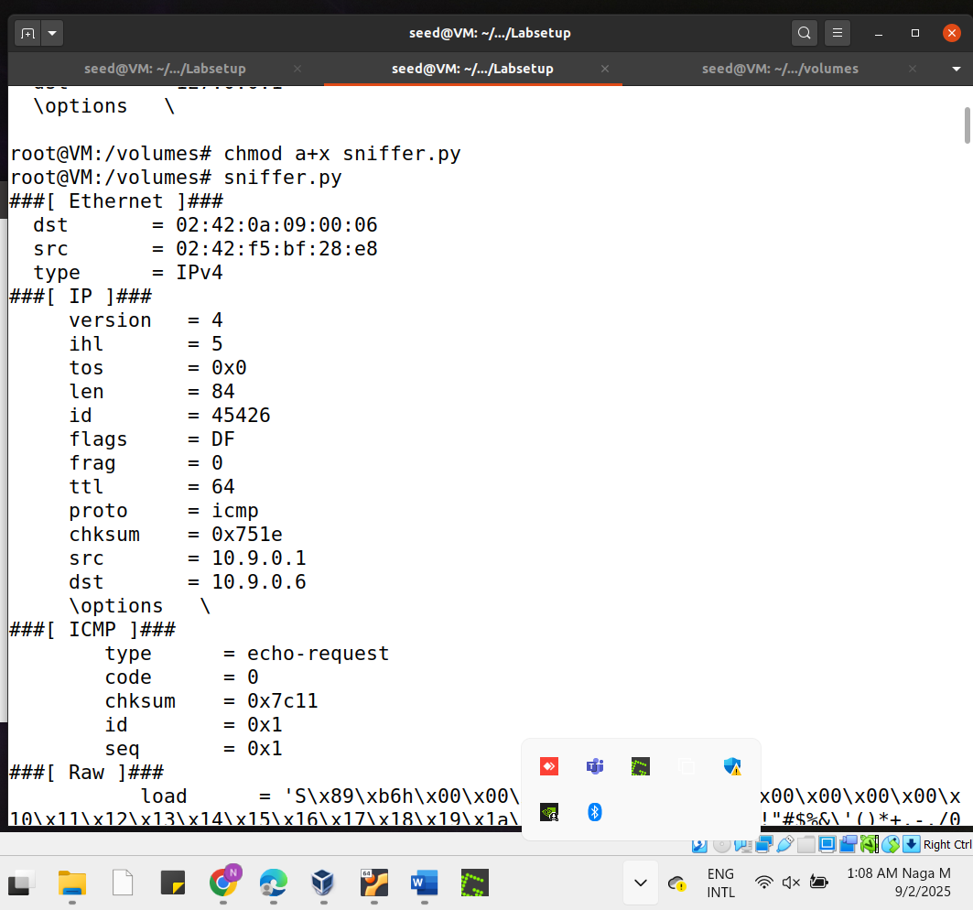

Lets run the program again and now without root privileges execute the sniffer.py
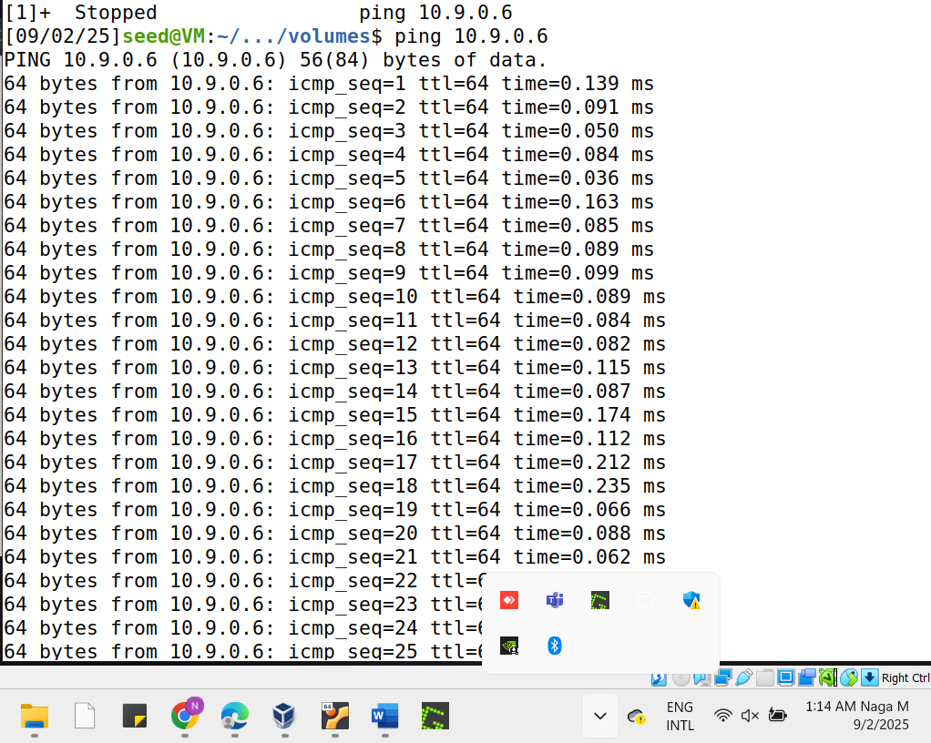
Open the root terminal and go back to seed account ,and run the program without the root privilege
#su seed
$sniffer.py
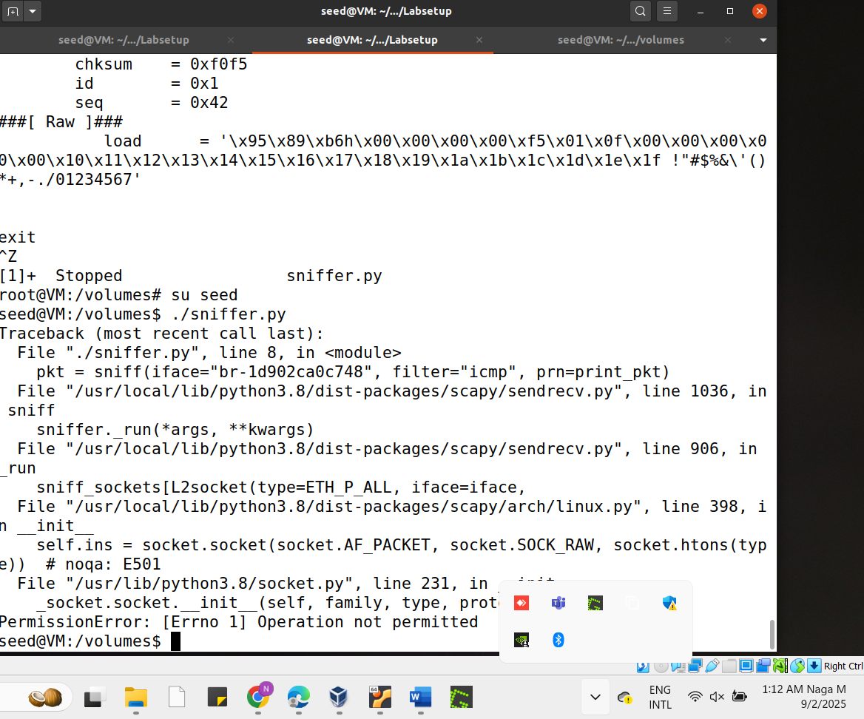
My observation: Lets see the output, as we got a permission Error and its saying that Operation not permitted. Because these kinds of sniffing tasks need root privileges without that we are not execute. Normal or Regular users doesn’t have access to perform these kinds of tasks because of security reasons and these tasks allow direct access to the packets on the network.

Task 1.1B:
Capture only the ICMP packet : Here, I just tried to send only Two packets. The python program was same as the above.

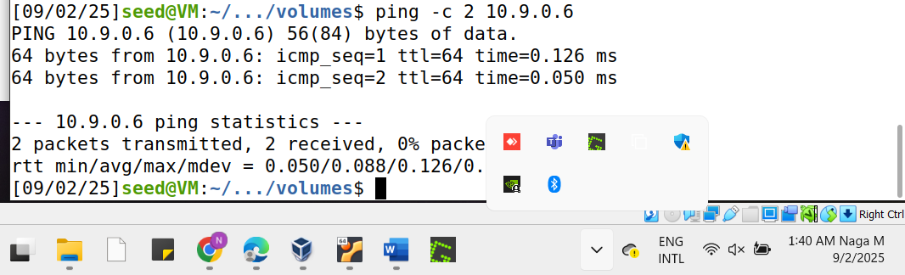
The Output here we see only ICMP packets are received

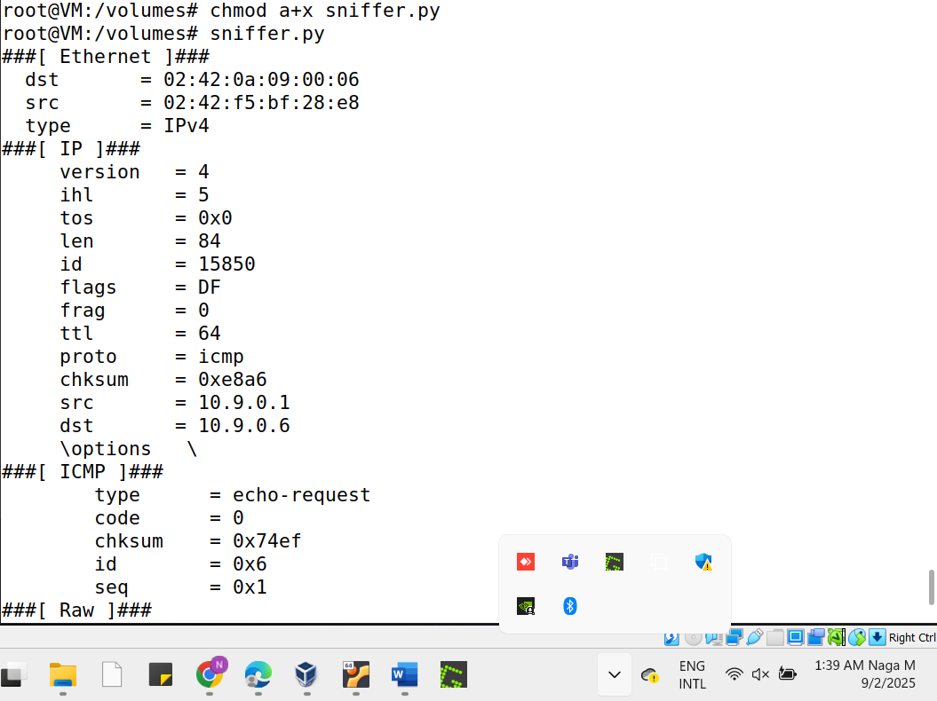

2. Capture any TCP packet that comes from a particular IP and with a destination port number 23:
Open the sniffer.py file and edit the filter as "tcp and src host 10.9.0.5 and dst port 23"
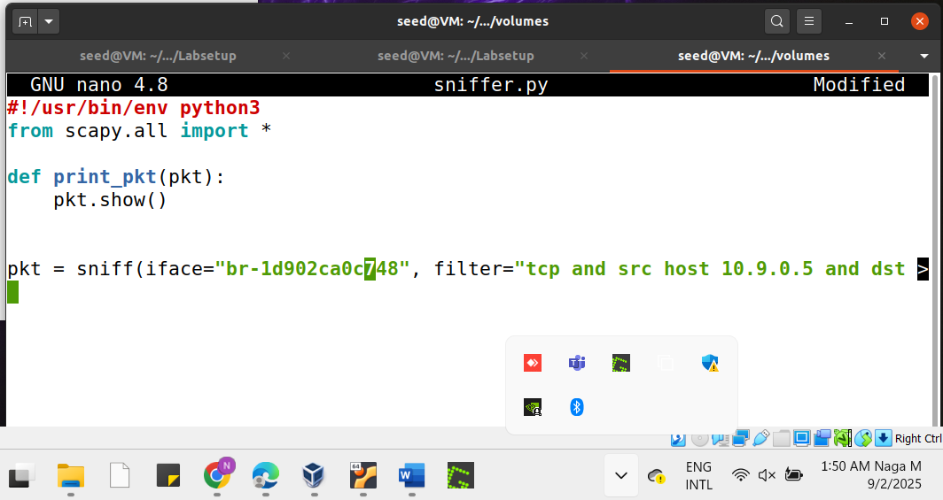
Here, we can run the command telnet, and see the output that the connection was established and we got the login to seed. Connection was successfully established means port 23 was open.

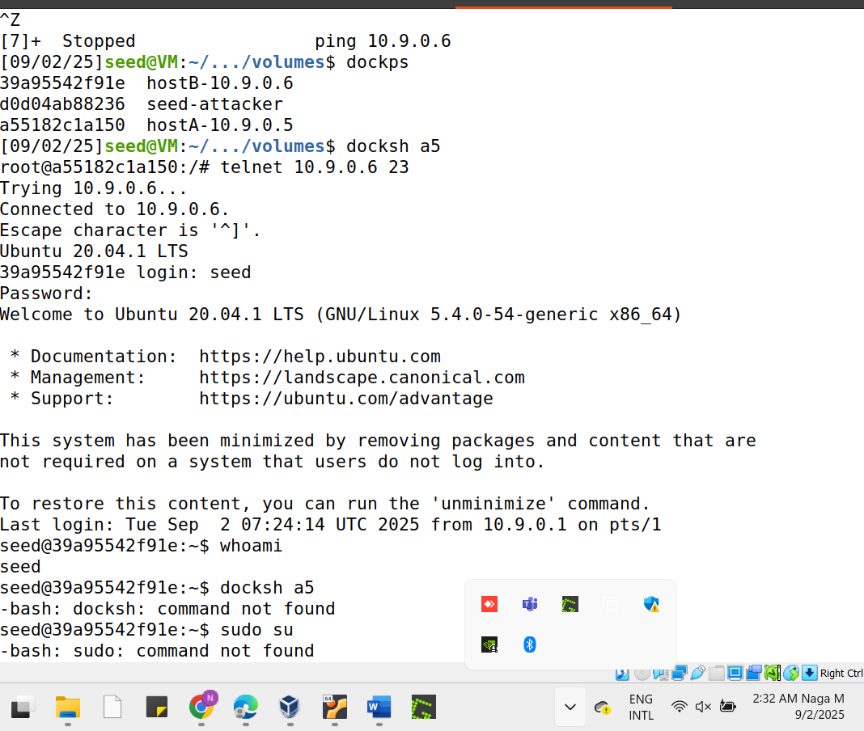

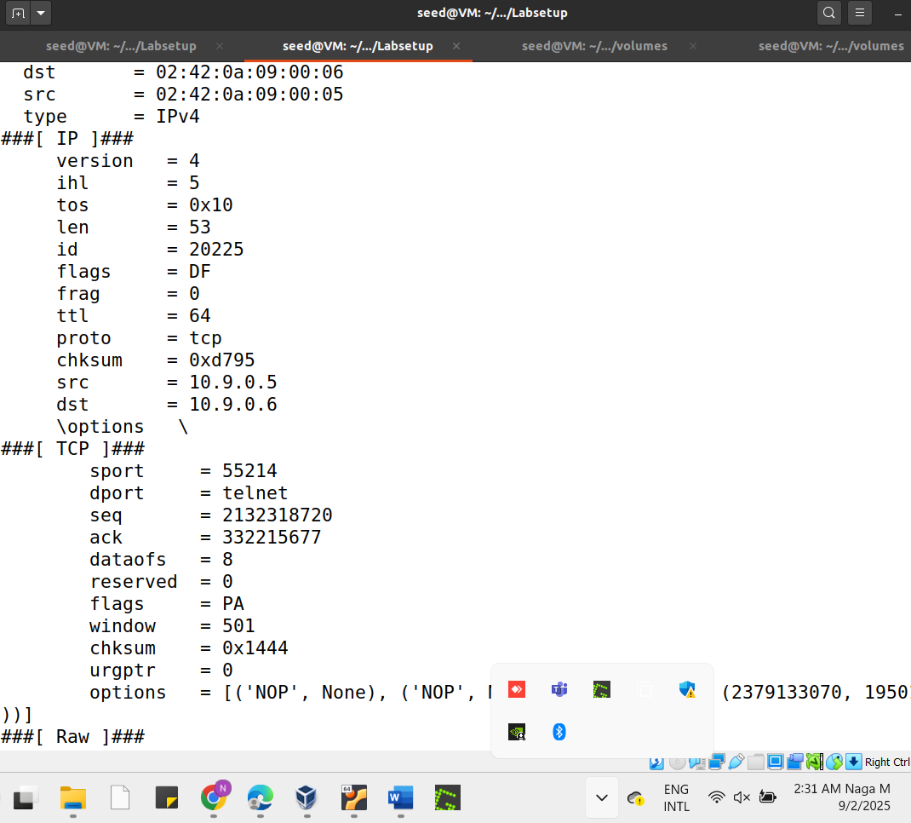
Packets to/from a particular subnet (NOT your VM’s subnet). You can pick any subnet, such as 128.230.0.0/16; you should not pick the subnet that your VM is attached to
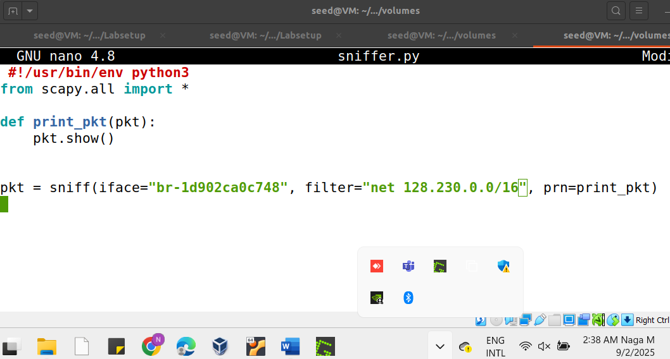
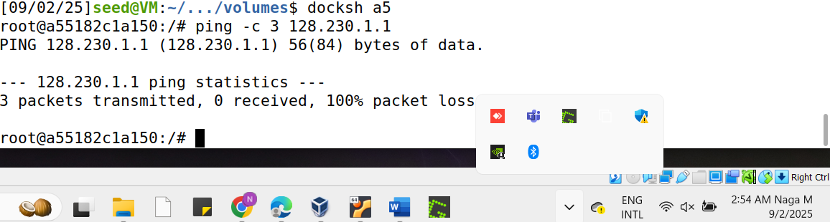
And From the attacker VM, we can see the output.
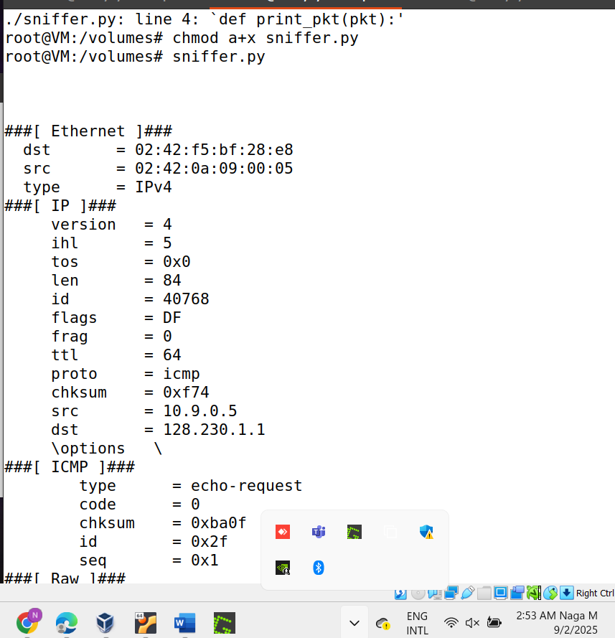

Task 1.2: Spoofing ICMP Packets

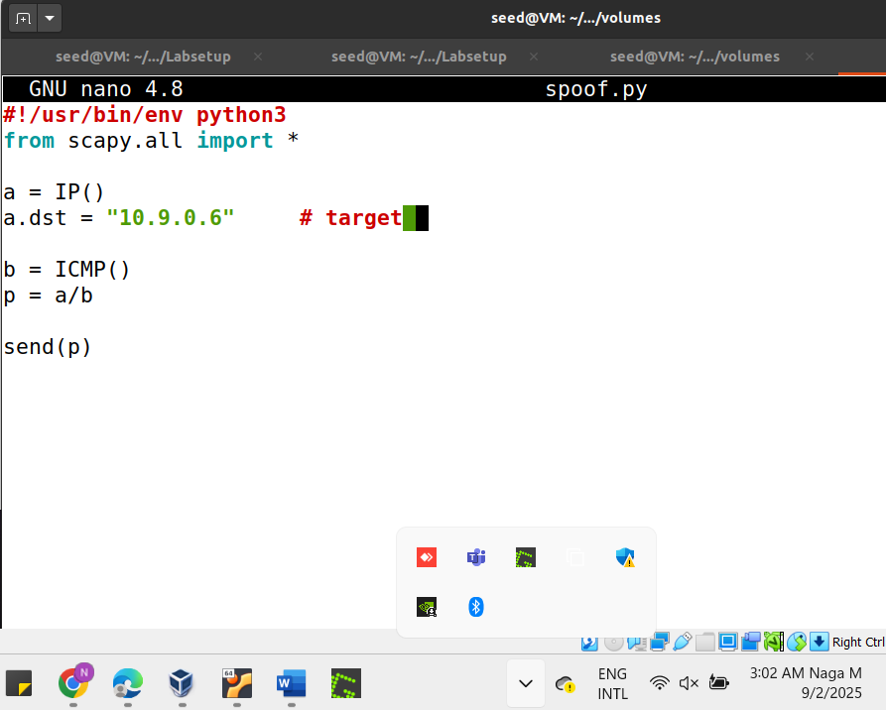
Lets execute the spoof.py file with the command chmod a+x spoof.py.
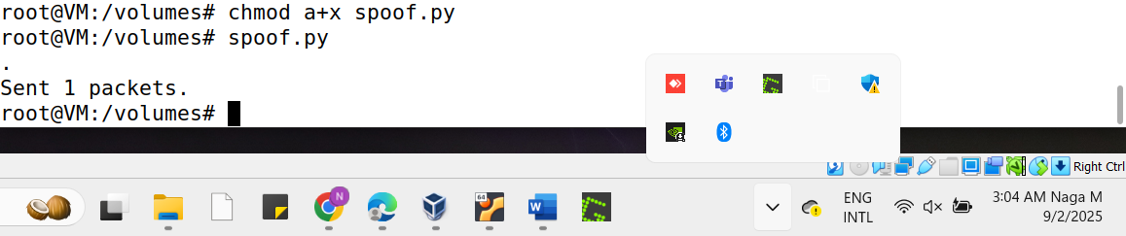
Here we that the packet was sent, so then open the wireshark and in filter select the ICMP and interface address then we can see the output as follows.
